Lab

Name: Muhammad Waqas Siddique Roll No: 232441

Class: BSCS-ev-IV-B

Course: Computer Networks

PC1 Configuration

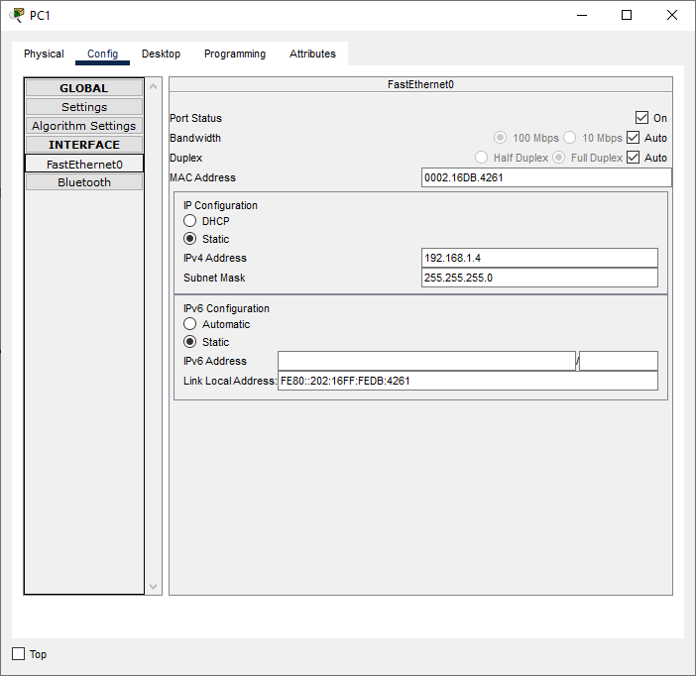

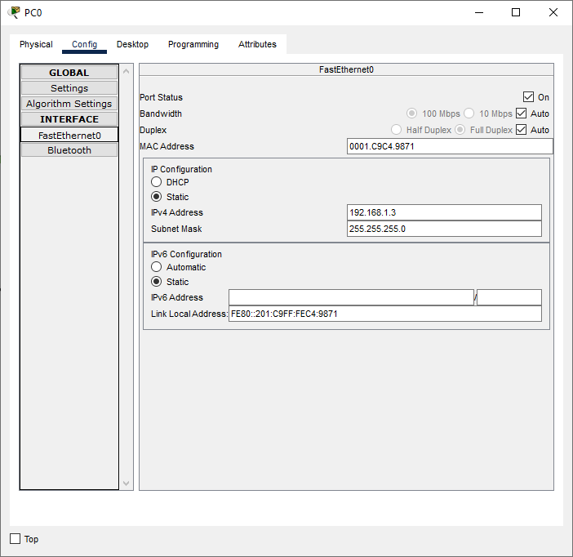

Mail Server Confiugation:

